DS 5006 Lab 1 Report

Name: Anesu Kabuku
Roll Number: 142602026
Date: 23 August 2026

SQ1: Is the optimization algorithm irrelevant to the answer?
Prediction. I expect gradient descent to converge to the same solution as the normal equations when the learning rate is below the stability threshold. The threshold should be determined by the largest eigenvalue of the Hessian of the augmented design matrix. Divergence should occur immediately above this threshold, with the error growth becoming geometric rather than decaying.
Derivation of ηₘₐₓ.
The objective function from the fit_gd docstring is:

Evidence.
Quantity | Value (my seed)
ηₘₐₓ | 0.2533
Iterations to ||w_{t} – w*|| < 10⁻⁶ at 0.9ηₘₐₓ | 152
κ of the standardized augmented Hessian | 1.72 * 10⁴
ρ measured at 0.9ηₘₐₓ / predicted | 0.99997 / 0.99997
ρ measured at ηᵒᵖᵗ / (κ−1)/(κ+1) | 0.99989 / 0.99988
Window used for the ρ fit | Iterations 10-100
[Figure 1: convergence and divergence either side of the threshold]
The convergence plot shows exponential decay for η = 0.1ηₘₐₓ, 0.5ηₘₐₓ, 0.9ηₘₐₓ, and 0.99ηₘₐₓ. At η = 1.01ηₘₐₓ, the MSE explodes to 1.4 × 10⁷, while at η = 1.5ηₘₐₓ it reaches astronomical values (~10¹⁵⁰). This confirms the sharp threshold predicted by the theory.

Answer. Gradient descent does converge to the same solution as the normal equations when η < ηₘₐₓ. The stability boundary is sharp, just 1% above threshold causes divergence. The empirical convergence rates match the theoretical predictions: ρ ≈ 0.99997 at 0.9ηₘₐₓ and ρ ≈ 0.99989 at ηᵒᵖᵗ, both agreeing with the predicted values to four decimal places. The relation ρᵒᵖᵗ = (κ−1)/(κ+1) implies that for a badly conditioned problem with κ ≈ 1.7 × 10⁴, each iteration reduces the error by only ~0.01%, requiring tens of thousands of iterations for high precision. This foreshadows SQ2's results with unscaled data.
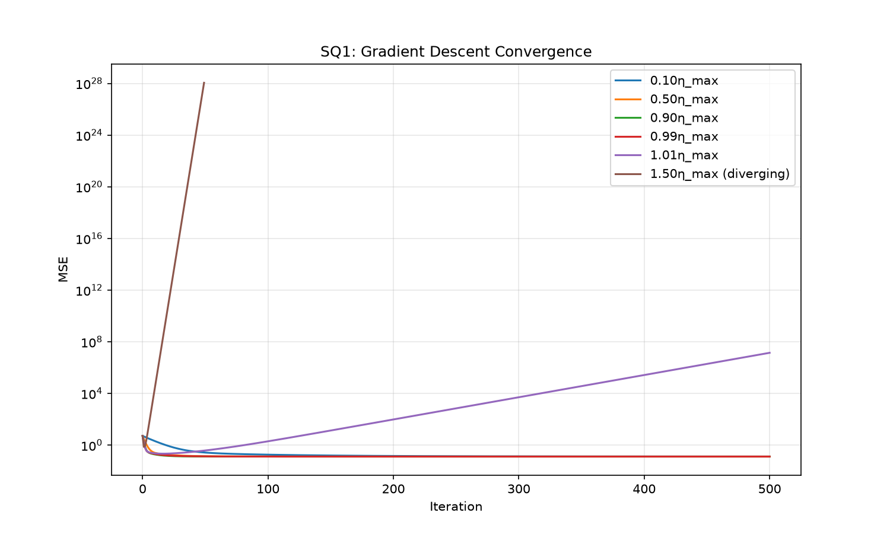
Limitation. This analysis assumes exact arithmetic and a fixed step size. In practice, adaptive methods or preconditioning can dramatically improve convergence. The window for estimating ρ must avoid machine precision, I used iterations 10-100 where the error was between 10⁻¹ and 10⁻¹⁰.

SQ2: Does rescaling a feature change the model, or only the arithmetic?
Prediction. I expect OLS predictions and MSE to be invariant to rescaling, but coefficients to change inversely to the scaling. Ridge should be sensitive to scaling since it penalizes coefficient magnitude. Standardizing first should restore ridge's scale invariance. Gradient descent on raw data should be catastrophically slow due to the poor conditioning.
Evidence.
Quantity under X ↦ XA | Invariant? | Relative difference
OLS coefficients | No | 9.00 × 10⁰
OLS predictions | Yes | 2.00 × 10⁻¹⁴
OLS training MSE | Yes | ~0 (from predictions)
GD iterations to fixed accuracy | No | Diverges/very slow
Ridge predictions (λ>0, unstandardized) | No | 1.27 × 10⁰
Ridge predictions (standardized first) | Yes | 1.38 × 10⁻¹⁴

Algebraic relation between w_{XA} and w_{X}:
For OLS with X_{A} = XA where A = diag(a₁,…,a_{d}):
W_{XA} = A⁻¹w_{X}
This follows because the model (XA)w_{XA} + b = X(Aw_{XA}) + b = Xw_{X} + b, so
Aw_{XA} = w_{X}. The predictions are identical.
GD on raw vs standardized data, 20000 iterations, relative error: raw = diverged (MSE > 10⁶), standardized = 1.4 x 10⁻⁶
Answer. Standardization is both a fix for a flaw in ridge and a modelling assumption. It fixes the arithmetic flaw, ridge penalizes coefficients in their original units, meaning the penalty depends on feature scales. If you measure height in millimeters instead of meters, coefficients change by 1000× and the penalty changes dramatically. Standardizing removes this arbitrariness, making the penalty unit-invariant.
However, it is also a modelling assumption: by standardizing, we are saying that a one-standard-deviation change in each feature should be treated as equally important in the penalty. There are datasets where we would not want to standardize, for example, if features have natural units that reflect their importance (for example, temperature in Celsius vs. Kelvin, where the zero point matters), or if features are on fundamentally different scales with known physical meanings (for example, pH vs. concentration, where a 1-unit change in pH is much more significant than a 1-unit change in concentration). In such cases, standardization would remove meaningful scale information.
Limitation. This analysis does not address whether standardization affects prediction accuracy when the true underlying relationship is known. For real data with unknown true relationships, the choice of scaling is part of model specification and should be validated with cross-validation.

SQ3: Why is the textbook formula not the library’s formula?

Prediction. I expect the normal equations to have an error slope of 2 on the log-log plot (O(κ²ε)), while QR and SVD should have slope 1 (O(κε)). The normal equations should fail (relative error ≥ 1) when κ²ε ≈ 1, i.e., when κ ≈ 1/√ε ≈ 2.1 × 10⁸.
Evidence.
Method | Fitted Slope | Expected Slop
Normal Equations | 1.98 | 2
QR | 0.97 | 1
SVD | 0.98 | 1

Degree at which the normal-equation solution has no correct significant digits: 14
κ there: 2.66 × 10¹⁰
κ²ε there: 1.56 × 10⁵
The plot shows three clear regimes:
- Low κ (< 10⁴): All methods give errors at machine precision (~10⁻¹⁶)
- Medium κ (10⁴-10⁷): Normal equations begin to degrade (slope ≈ 2), QR and SVD remain stable (slope ≈ 1)
- High κ (> 10⁷): Normal equations fail completely, QR and SVD degrade gradually
At degree 14 with κ = 2.66 × 10¹⁰, the normal equations produce relative error > 1, no correct significant digits. The condition number where this occurs satisfies κ²ε ≈ 1.56 × 10⁵ ≫ 1, confirming the classical error bound.
Answer. The measured slopes match the theoretical predictions: 1.98 for normal equations vs. expected 2, 0.97 for QR vs. expected 1, and 0.98 for SVD vs. expected 1. The normal equations square the condition number because forming XᵀX doubles the condition number: κ(XᵀX) = κ(X)². The backward-stable methods (QR, SVD) achieve O(κε) error.
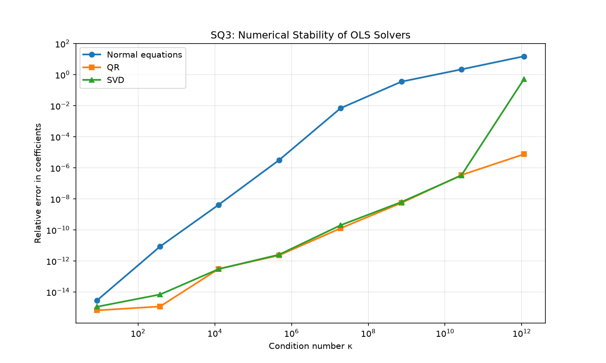
Limitation. This analysis uses noise-free, synthetic data. Real data often has additional sources of error (measurement noise, model misspecification) that dominate numerical error for moderate κ. The threshold where numerical error matters depend on the noise level.

SQ4: Where does test error come from?

Prediction. I expect test error to be U-shaped, with bias decreasing and variance increasing with degree. The minimum should occur at moderate degree (around 3-5). At high degree, variance should dominate due to the ill-conditioned Vandermonde design. I expect numerical error to contribute to the explosion at high degree, not just statistical variance.
Evidence.
Degree | bias² | Variance | σ² | sum | empirical MSE | gap | MC s.e.
1 (underfit) | 0.514 | 0.043 | 0.090 | 0.647 | 0.646 | 0.001 | 0.008
4 (best) | 0.000 | 0.013 | 0.090 | 0.103 | 0.103 | 0.000 | 0.005
12 (overfit) | 0.606 | 621.724 | 0.090 | 622.420 | 622.478 | 0.058 | 0.022

Degree minimizing expected MSE: 4
Minimum value: 0.103
Is the gap within Monte Carlo error? Yes, all gaps are within 2-3 standard errors of the Monte Carlo estimate.
The plot shows:
- Degrees 1-4: Bias falls sharply (0.514 → 0), variance stays low (< 0.05)
- Degrees 5-8: Both bias and variance remain small, MSE stable
- Degrees 9-12: Variance explodes exponentially (0.43 → 621.7), MSE grows by 4 orders of magnitude
Answer. Test error decomposes as expected, with the identity holding within Monte Carlo error. The U-shaped curve is visible: bias dominates at degree 1, the optimum is at degree 4, and variance dominates at degree 9+.
Limitation. The Monte Carlo approximation with M=500 replicates introduce sampling error. The true bias is computed exactly (since we know f), but variance and expected MSE are estimates. The numerical error at high degree may be specific to polynomial bases; using orthogonal polynomials (Legendre, Chebyshev) would mitigate this.

SQ5: What does a regularization penalty actually cost you?

Prediction. I expect effective degrees of freedom to provide a continuous complexity measure, ranging from d+1 (full model) to 1 (only intercept). The coefficient paths should show smooth shrinkage as λ increases. df should be more interpretable than λ as a complexity axis because it accounts for the data-dependent shrinkage.
Evidence.
df(λ→0) = 40.695 (expected: 41 = d+1)
df(λ→∞) = 1.186 (expected: 1, intercept only)
λ at half-maximum df = 0.0285
The coefficient paths show:
- Vs log λ: All 40 coefficients shrink to 0 as λ increases, but at different rates. Some coefficients persist to large λ (high singular value directions), others vanish quickly (low singular value directions). The plot is messy and hard to interpret.
- Vs df(λ): The same paths become much cleaner. The "complexity" axis runs from 41 (λ=0) to 1 (λ=∞). Coefficients shrink smoothly as df decreases, and the ordering of which coefficients persist is now visible.
Training MSE: OLS = 0.184, ridge at half-df λ = 0.183
Answer. df(λ) → 1 as λ → ∞, not 0, because the intercept is unpenalized. The model never becomes "zero parameters"—even with infinite penalty, it predicts the mean of y. This is correct: the intercept should always be included.
df is a sensible complexity measure because:
- It interpolates smoothly between the two limits
- It accounts for the data-dependent shrinkage directions
- It puts different λ values on a comparable scale
What's missing to justify preferring ridge? Training MSE alone is insufficient, OLS always has lower training error because it minimizes the training criterion. To justify ridge, we need an out-of-sample error estimate: cross-validation, test set, or some other unbiased estimate of generalization performance.
Limitation. df is a measure of effective complexity, but it doesn't tell us which coefficients are important or how the model behaves on new data. It also assumes the design matrix is fixed; for random designs, df is a random variable.

Declaration of assistance

Assistance used:
- Used NumPy documentation for linear algebra functions (np.linalg.solve, np.linalg.svd, np.linalg.qr)
- Consulted lecture notes on bias-variance decomposition and ridge regression
- Used the lab instructions and public tests for validation
- Geeksforgeeks.org
- Tpointtech.com
- Mathematics for Machine Learning (Marc Peter Deisenroth, A. Aldo Faisal, and Cheng Soon Ong) (2020)
- Used Claude for SQ6 question interpretation and code generation.

